Name : Khush Pithva 24BCE174
Subject : Data Structure (2CS501)
Practical no.: 4A
AIM : Create simple Queue data structure using Array/Linked List and implement following functions:
i. Enque ii. Dequeue iii. Display
INPUT :
#include <bits/stdc++.h>
using namespace std;

const int MAX = 3;
int arr[MAX];
int front = -1, rear = -1;

void enque(int x);
void deque1();
void display();

bool isempty() {
return (front == -1 && rear == -1);
}

bool isfull() {
return (rear == MAX - 1);
}

void enque(int x) {
if (isfull()) {
cout << "Queue is Full!" << endl;
return;
}
if (isempty()) front = 0;
arr[++rear] = x;
}

void deque1() {
if (isempty()) {
cout << "Empty Queue" << endl;
return;
}
int ans = arr[front];
cout << "Element : " << ans << " dequeued" << endl;

if (front == rear) {
front = rear = -1;
} else {
front++;
}
}

void display() {
if (isempty()) {
cout << "Empty Queue" << endl;
return;
}
cout << "Queue Elements: ";
for (int i = front; i <= rear; i++) {
cout << arr[i] << " ";
}
cout << endl;
}

int main() {
bool t = true;
while (t) {
cout << "----X----X----" << endl;
cout << "1.enque \n2.deque \n3.display \n4.break\n";
cout << "Enter Choice : ";
int c;
cin >> c;
switch (c) {
case 1: {
cout << "Enter : ";
int x; cin >> x;
enque(x);
break;
}
case 2:
deque1();
break;
case 3:
display();
break;
case 4:
t = false;
break;
default:
cout << "Invalid Choice" << endl;
}
}
return 0;
}OUTPUT :
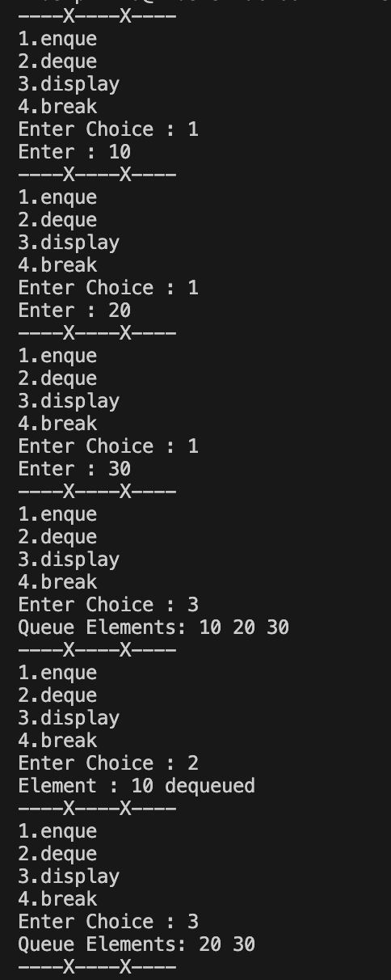

Practical no.: 4B
AIM : Create double ended queue data structure using Linked List and implement following functions:
i. Insert front ii. Insert rear iii. Delete front iv. Delete rear v. Display
Implement following programs related to Queue data structure

#include <bits/stdc++.h>
using namespace std;

struct Node {
int data;
Node* prev;
Node* next;
Node(int val) : data(val), prev(NULL), next(NULL) {}
};

class Deque {
Node* front;
Node* rear;

public:
Deque() {
front = rear = NULL;
}

void insertFront(int x) {
Node* newNode = new Node(x);
if (!front) {
front = rear = newNode;
} else {
newNode->next = front;
front->prev = newNode;
front = newNode;
}
cout << x << " inserted at front" << endl;
}

void insertRear(int x) {
Node* newNode = new Node(x);
if (!rear) {
front = rear = newNode;
} else {
rear->next = newNode;
newNode->prev = rear;
rear = newNode;
}
cout << x << " inserted at rear" << endl;
}

void deleteFront() {
if (!front) {
cout << "Deque is empty" << endl;
return;
}
int val = front->data;
Node* temp = front;
if (front == rear) {
front = rear = NULL;
} else {
front = front->next;
front->prev = NULL;
}
delete temp;
cout << val << " deleted from front" << endl;
}

void deleteRear() {
if (!rear) {
cout << "Deque is empty" << endl;
return;
}
int val = rear->data;
Node* temp = rear;
if (front == rear) {
front = rear = NULL;
} else {
rear = rear->prev;
rear->next = NULL;
}
delete temp;
cout << val << " deleted from rear" << endl;
}

void display() {
if (!front) {
cout << "Deque is empty" << endl;
return;
}
cout << "Deque elements: ";
Node* temp = front;
while (temp) {
cout << temp->data << " ";
temp = temp->next;
}
cout << endl;
}
};

int main() {
Deque dq;
bool t = true;

while (t) {
cout << "\n----X----X----" << endl;
cout << "1. Insert Front\n2. Insert Rear\n3. Delete Front\n4. Delete Rear\n5. Display\n6. Exit\n";
cout << "Enter choice: ";
int c, x;
cin >> c;

switch (c) {
case 1:
cout << "Enter value: ";
cin >> x;
dq.insertFront(x);
break;
case 2:
cout << "Enter value: ";
cin >> x;
dq.insertRear(x);
break;
case 3:
dq.deleteFront();
break;
case 4:
dq.deleteRear();
break;
case 5:
dq.display();
break;
case 6:
t = false;
break;
default:
cout << "Invalid choice" << endl;
}
}

return 0;
}OUTPUT :
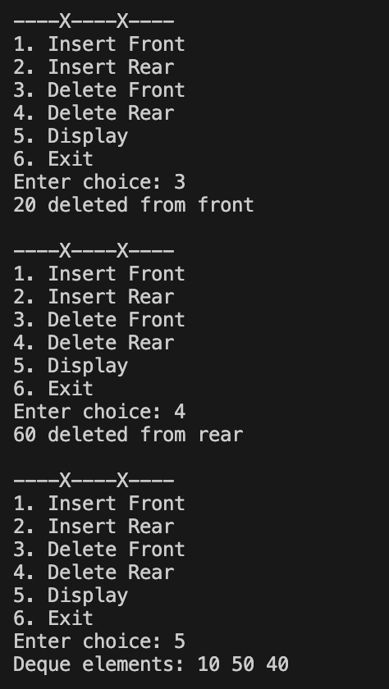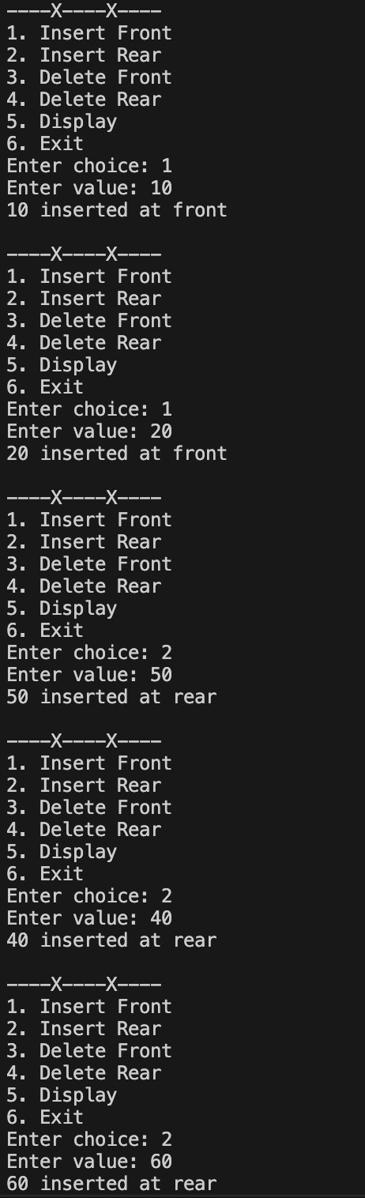
LEETCODE
- Design Circular Queue
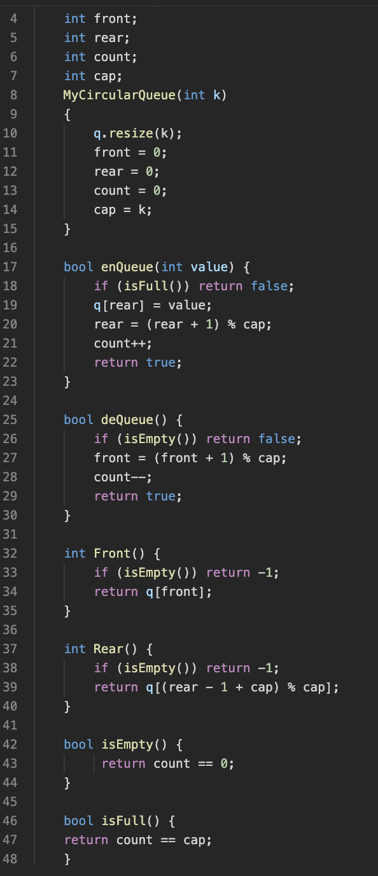
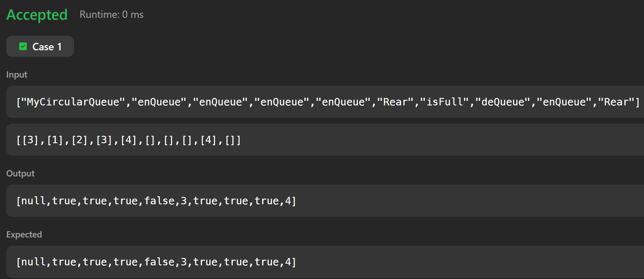
- First Unique Character in a String
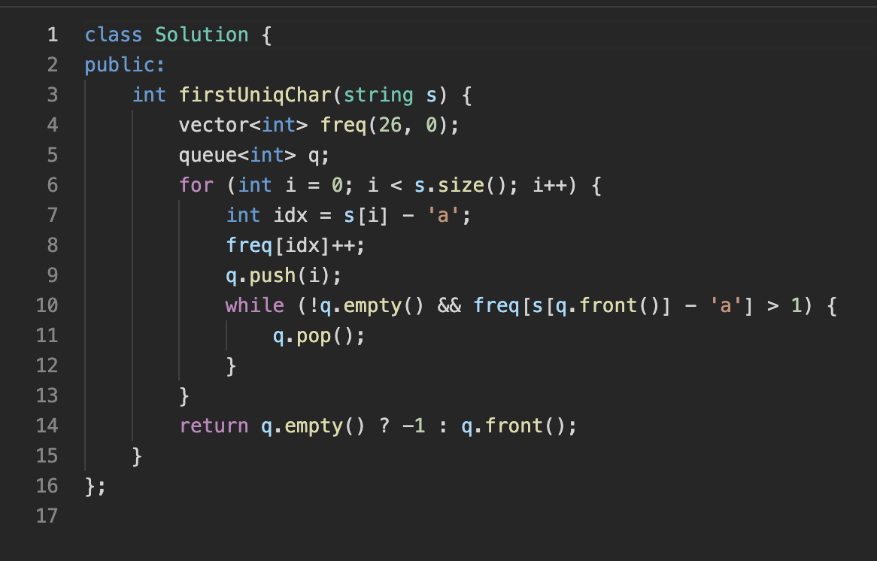

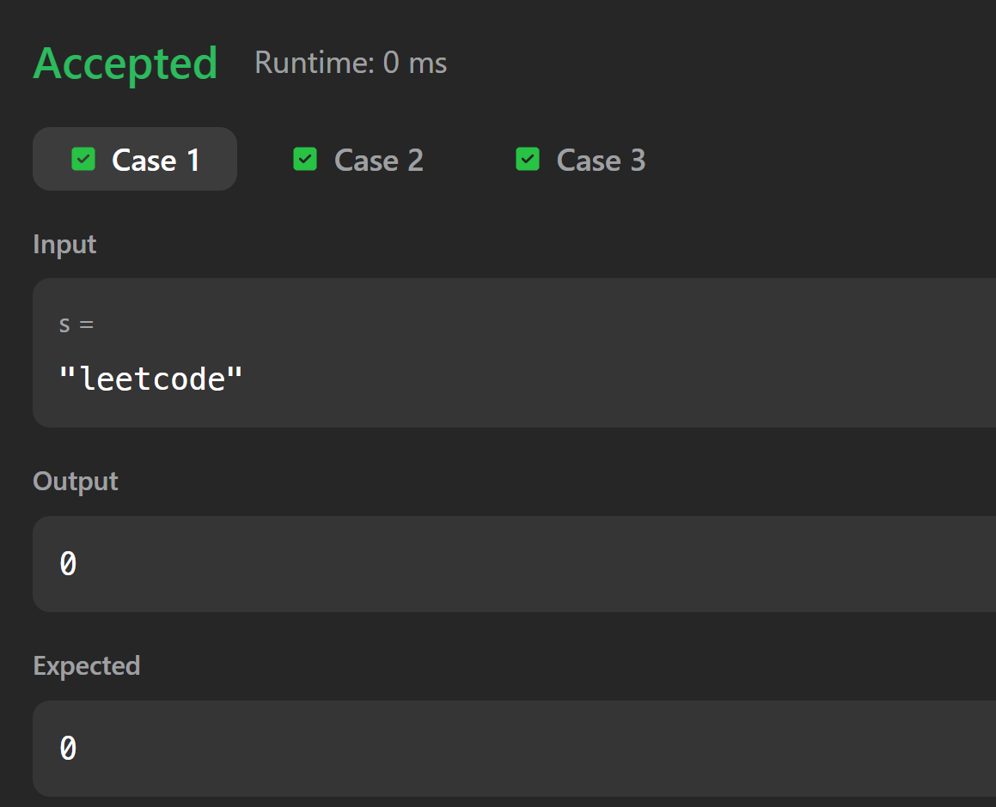

- Number of Students unable to eat Lunch

